**NERIM GROUP OF INSTITUTIONS**

# **Project Topic: Influence of Music on mental health.**



**Submitted by-**

**Name:** Rocktim Jyoti Das

**Course:** BBA 6th Semester ; Sec : C

**Specialization:** HR

**Reg. No. :** 20480889

**Session:** 2020-2023

**University name:**  Dibrugarh University

**CERTIFICATE**

This is to certify that Rocktim Jyoti Das, a student of NERIM Group of Institutions, Guwahati has successfully completed this project on the topic of “Web designing: Influence of Music on Mental Health” under the guidance of Mr. Shekhar Sinha for partial fulfillment of the requirement Bachelor of Business Administration(BBA), embodies the bonafide work done by him under my supervision.

Mr. Shekhar Sinha

Project guide

**ACKNOWLEDGEMENT**

I would like to express my gratitude to my Computer Teachers, Mr. Manabendra Nath and Mr. Shekhar Sinha for their guidance and support for completion of my project.

I would also like to express my thanks to our respectable Chairman Dr. Zoii Nath Sarma , our respectable Director Madam Prof. (Dr.) Sangeeta Tripathy and our HOD Dr. Sayanika Deka Sarma for providing me all the opportunities and facilities that were required.

|  |  |  |
| --- | --- | --- |
| **CONTENTS** | | |
| **Sl. No.** | **Particulars** | **Page No.** |
| 1. | HOME | 5 |
| 2. | HOME(html) | 6-7 |
| 3. | HOME(CSS) | 8-13 |
| 4. | PAGE-2 | 14 |
| 5. | PAGE-2(html) | 15-16 |
| 6. | PAGE-3 | 17 |
| 7. | PAGE-3(html) | 18-19 |
| 8. | PAGE-4 | 20 |
| 9. | PAGE-4(html) | 21-22 |
| 10. | PAGE-4,6,8(Combine CSS) | 23 |
| 11. | JAVASCRIPT | 24 |
| 12. | CONCLUSION | 25 |
| 13. | BIBLIOGRAPHY | 26 |

**1.Home.**

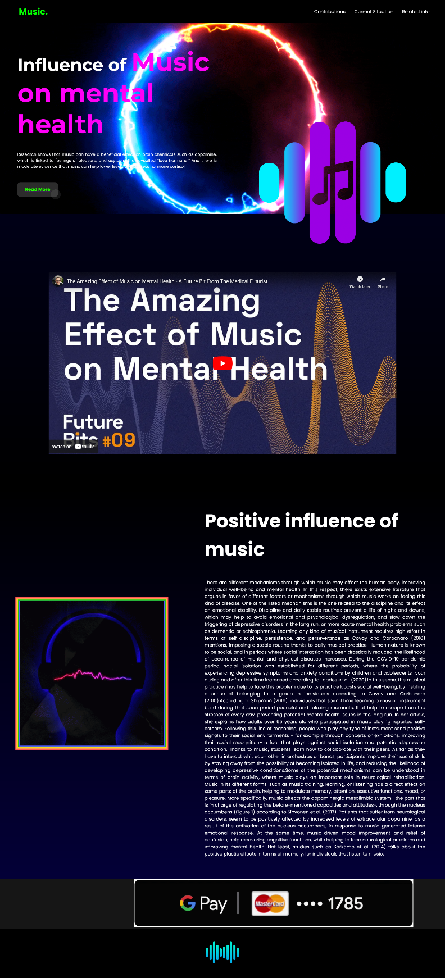

**2.Home(html)**

<!DOCTYPE html>

<html lang="en">

<head>

<meta charset="UTF-8">

<meta http-equiv="X-UA-Compatible" content="IE=edge">

<meta name="viewport" content="width=device-width, initial-scale=1.0">

<title>music</title>

<link rel="stylesheet" href="style.css">

</head>

<body>

<nav id="nav">

<div class="head">

<a href="#" class="logo">Music.</a>

<div class="hamburger">

<div class="line"></div>

<div class="line"></div>

<div class="line"></div>

<p class="cross v">&#9587</p>

</div>

</div>

<ul class="list v">

<li class="item"><a href="page2.html">Contributions</a></li>

<li class="item"><a href="page3.html">Current Situation</a></li>

<li class="item"><a href="page4.html">Related info.</a></li>

</ul>

</nav>

<!-- hero -->

<div class="parent">

<div class="child">

<h1> Influence of <span> Music on mental health

</span></h1>

<P> Research shows that music can have a beneficial effect on brain chemicals such as dopamine, which is linked to feelings of pleasure, and oxytocin, the so-called “love hormone.” And there is moderate evidence that music can help lower levels of the stress hormone cortisol.</P>

<a href="#main-section">

<button class="button-86" role="button"><b>Read More</b></button>

</a>

</div>

<div class="child2">

<img class="plane" src="—Pngtree—music logo_8736577.png" alt="" width="100%">

</div>

</div>

</div>

<!-- video -->

<div id="myvideo">

<center>

<iframe width="1200" height="630" src="https://www.youtube.com/embed/zJ2YGLuzGfo" title="YouTube video player" frameborder="0" allow="accelerometer; autoplay; clipboard-write; encrypted-media; gyroscope; picture-in-picture; web-share" allowfullscreen></iframe>

</center>

</div>

<section id="main-section">

<div class="container">

<div class="content1">

<div class="image-container">

<img src="music-beat.gif" alt="">

</div>

<div class="text">

<h1> Positive influence of music</h1>

<p>There are different mechanisms through which music may affect the human body, improving individual well-being and

mental health. In this respect, there exists extensive literature that argues in favor of different factors or mechanisms

through which music works on facing this kind of disease. One of the listed mechanisms is the one related to the

discipline and its effect on emotional stability. Discipline and daily stable routines prevent a life of highs and downs,

which may help to avoid emotional and psychological dysregulation, and slow down the triggering of depressive disorders

in the long run, or more acute mental health problems such as dementia or schizophrenia. Learning any kind of musical

instrument requires high effort in terms of self-discipline, persistence, and perseverance as Covay and Carbonaro (2010)

mentions, imposing a stable routine thanks to daily musical practice.

Human nature is known to be social, and in periods where social interaction has been drastically reduced, the

likelihood of occurrence of mental and physical diseases increases. During the COVID-19 pandemic period, social

isolation was established for different periods, where the probability of experiencing depressive symptoms and anxiety

conditions by children and adolescents, both during and after this time increased according to Loades et al. (2020).In this sense, the musical practice may help to face this problem due to its practice boosts social well-being, by instilling a

sense of belonging to a group in individuals according to Covay and Carbonaro (2010).According to Shipman (2016), individuals that spend time learning a musical instrument build during that span

period peaceful and relaxing moments, that help to escape from the stresses of every day, preventing potential mental

health issues in the long run. In her article, she explains how adults over 65 years old who participated in music playing

reported self-esteem. Following this line of reasoning, people who play any type of instrument send positive signals to

their social environments - for example through concerts or exhibitions, improving their social recognition- a fact that

plays against social isolation and potential depression condition. Thanks to music, students learn how to collaborate with

their peers. As far as they have to interact whit each other in orchestras or bands, participants improve their social skills

by staying away from the possibility of becoming isolated in life, and reducing the likelihood of developing depressive

conditions.Some of the potential mechanisms can be understood in terms of brain activity, where music plays an important role in

neurological rehabilitation. Music in its different forms, such as music training, learning, or listening has a direct effect on

some parts of the brain, helping to modulate memory, attention, executive functions, mood, or pleasure. More specifically,

music affects the dopaminergic mesolimbic system -the part that is in charge of regulating the before-mentioned capacities.and attitudes-, through the nucleus accumbens (Figure 1) according to Sihvonen et al. (2017). Patients that suffer from

neurological disorders, seem to be positively affected by increased levels of extracellular dopamine, as a result of the

activation of the nucleus accumbens, in response to music-generated intense emotional response. At the same time,

music-driven mood improvement and relief of confusion, help recovering cognitive functions, while helping to face

neurological problems and improving mental health. Not least, studies such as Särkämö et al. (2014) talks about the

positive plastic effects in terms of memory, for individuals that listen to music.

</p>

</div>

</div>

</div>

</section>

<div class="color">

<marquee behavior="alternate" direction="left">

<a href="https://play.google.com/store/apps/details?id=com.google.android.apps.nbu.paisa.user&hl=en&gl=US">

<img src="dynamic button.gif" alt="">

</a>

</marquee>

</div>

<div class="footer">

<center>

<img src="sound-waves.png" alt="" width="8%">

</center>

</div>

<script src="script.js"></script>

</body>

</div>

</html>

**3.Home(CSS)**

@import url('https://fonts.googleapis.com/css2?family=Carter+One&family=Lobster&family=Montserrat:wght@100;300;500;700;900&family=Open+Sans:wght@300;700;800&family=Poppins:wght@100;200;300;400;500;700&display=swap');

body{

margin: 0px;

padding: 0px;

box-sizing: border-box;

font-family: 'poppins',sans-serif;

}

#nav{

display: flex;

align-items: center;

justify-content: space-between;

width: 100vw;

height: 80px;

background-color: #000000;

}

.logo{

color:rgb(4, 255, 0);

margin: 7px 25px;

padding: 1px 7px;

font-size: 30px;

text-decoration: none;

font-weight: bold;

font-family: 'poppins',sans-serif;

padding-left: 40px;

}

.list{

display: flex;

align-items: center;

justify-content: center;

list-style: none;

margin: 10px 35px;

}

.item{

margin: 7px 15px;

}

.item a{

color:#fff;

text-decoration: none;

}

.item a:hover{

color: rgb(72, 255, 0);

text-decoration: underline;

}

.hamburger{

display: none;

margin: 7px 25px;

cursor: pointer;

}

.line{

width: 30px;

height: 5px;

margin: 3px;

border: 1.5px solid #fff;

}

.cross{

color: rgb(8, 6, 96);

text-align: center;

font-size: 18px;

font-weight: bold;

width: 35px;

}

@media only screen and (max-width: 998px)

{

#nav{

flex-direction: column;

height: auto;

}

.head{

display: flex;

align-items: center;

justify-content: space-between;

width: 100vw;

}

.hamburger{

display: block;

margin: 15px 25px;

}

.logo{

font-size: 29px;

margin: 15px 25px;

font-weight: bold;

}

.list{

flex-direction: column;

padding: 50px;

}

.v{

display: none;

}

}

.parent{

display: flex;

height: 90vh;

background-image: url(music.gif);

background-position: center;

background-size: cover;

}

.child{

width: 50%;

padding-left: 60px;

padding-top: 40px;

}

.child2{

width: 50%;

padding-top: 200px;

}

.child h1{

font-size: 60px;

font-weight: bold;

color: #ffffff;

font-family: 'montserrat',sans-serif;

}

.child p{

padding-bottom: 30px;

padding-right: 50px;

color:#fff;

font-size: 14px;

text-align: justify;

}

span{

color:#ff00f7;

font-size: 5.5rem;

}

.plane{

width: 95%;

}

@media only screen and (max-width:768px) {

.parent{

display: inline-block;

}

.child h1{

font-size: 40px;

}

span{

font-size: 65px;

}

.child p{

font-size: 13px;

}

.plane{

display: none;

}

}

/* CSS */

.button-86 {

all: unset;

width: 100px;

height: 30px;

font-size: 16px;

background: transparent;

border: none;

position: relative;

color: #22ff00;

cursor: pointer;

z-index: 1;

padding: 10px 20px;

display: flex;

align-items: center;

justify-content: center;

white-space: nowrap;

user-select: none;

-webkit-user-select: none;

touch-action: manipulation;

}

.button-86::after,

.button-86::before {

content: '';

position: absolute;

bottom: 0;

right: 0;

z-index: -99999;

transition: all .4s;

}

.button-86::before {

transform: translate(0%, 0%);

width: 100%;

height: 100%;

background: #2c2c2c;

border-radius: 10px;

}

.button-86::after {

transform: translate(10px, 10px);

width: 35px;

height: 35px;

background: #ffffff15;

backdrop-filter: blur(5px);

-webkit-backdrop-filter: blur(5px);

border-radius: 50px;

}

.button-86:hover::before {

transform: translate(5%, 20%);

width: 110%;

height: 110%;

}

.button-86:hover::after {

border-radius: 10px;

transform: translate(0, 0);

width: 100%;

height: 100%;

}

.button-86:active::after {

transition: 0s;

transform: translate(0, 5%);

}

.ads{

width: 100%;

height: 155px;

background-color:#ffffff;

}

#myvideo {

padding-top: 200px;

background-image: linear-gradient(rgb(0, 0, 23),black);

padding-bottom: 100px;

}

#myvideo h1{

font-size: 90px;

padding-bottom: 15px;

padding-top: 100px;

color: #fff;

}

#myvideo p{

color: #fff;

font-size: 18px;

padding-top: 20px;

}

.suuu{

padding-top: 40px;

}

.amazon{

background-color:rgb(0, 255, 204);

}

.container{

background-image: linear-gradient(rgb(0, 0, 0),rgb(4, 0, 56));

min-height: 100vh;

}

.content1{

max-width: 1400px;

margin: 0 auto;

display: flex;

}

.image-container img{

box-shadow: rgb(85, 91, 255) 0px 0px 0px 3px, rgb(31, 193, 27) 0px 0px 0px 6px, rgb(255, 217, 19) 0px 0px 0px 9px, rgb(255, 156, 85) 0px 0px 0px 12px, rgb(255, 85, 85) 0px 0px 0px 15px;

margin-top: 200px;

}

.text{

padding-left: 10%;

padding-top: 20px;

}

.content1 h1{

font-size: 65px;

color:#fff;

}

.image-container{

padding-top: 200px;

}

.content1 p{

text-align: justify;

color: #ffffff;

padding-bottom: 60px;

}

.wiki{

padding-top: 20px;

text-align: end;

padding-bottom: 80px;

}

.advvv{

width:20%;

}

@media only screen and (max-width:768px) {

.image-container{

display: none;

}

.content1 h1{

font-size: 40px;

padding-right: 13px;

}

.content1 p{

font-size: 10px;

text-align: justify;

padding-right: 40px;

}

.amazon{

padding-top:150px;

}

#myvideo h1{

font-size: 30px;

}

}

.footer{

width: 100%;

height: 150px;

background-color:#000000;

padding-top: 20px;

}

html{

scroll-behavior: smooth;

}

.color{

background-color: rgb(22, 22, 22);

}

**4.Page2**

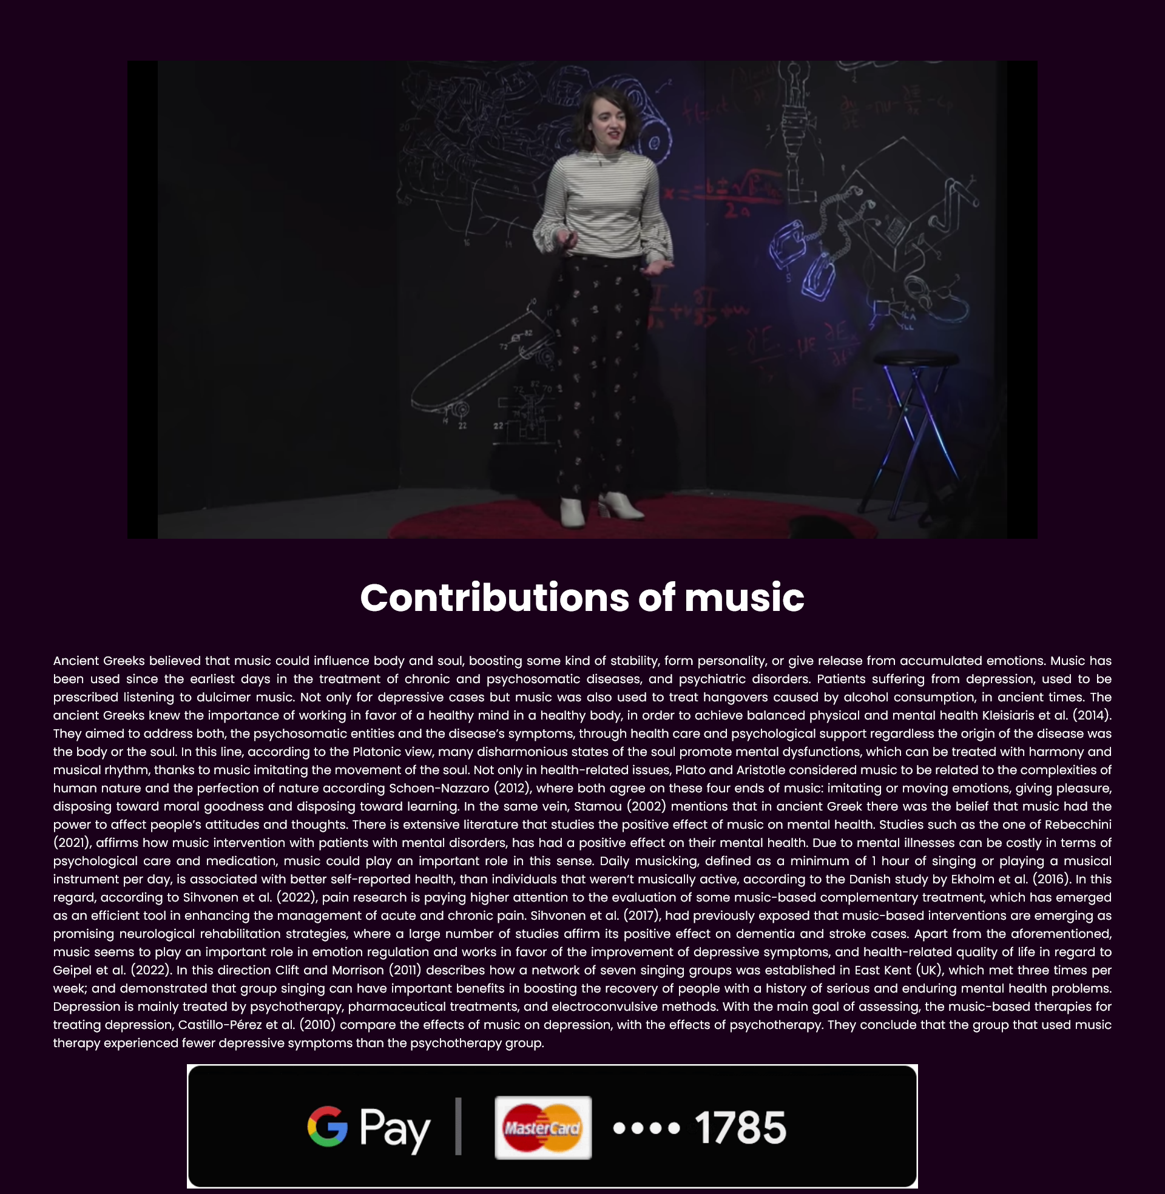

**5.Page2(html)**

<!DOCTYPE html>

<html lang="en">

<head>

<meta charset="UTF-8">

<meta http-equiv="X-UA-Compatible" content="IE=edge">

<meta name="viewport" content="width=device-width, initial-scale=1.0">

<title>p2</title>

<link rel="stylesheet" href="style2.css">

</head>

<body>

<center>

<div class="content">

<iframe width="1200" height="630" src="https://www.youtube.com/embed/jPDKi-i618U" title="YouTube video player" frameborder="0" allow="accelerometer; autoplay; clipboard-write; encrypted-media; gyroscope; picture-in-picture; web-share" allowfullscreen></iframe>

<h1> Contributions of music</h1>

<p>Ancient Greeks believed that music could influence body and soul, boosting some kind of stability, form personality, or

give release from accumulated emotions. Music has been used since the earliest days in the treatment of chronic and

psychosomatic diseases, and psychiatric disorders. Patients suffering from depression, used to be prescribed listening to

dulcimer music. Not only for depressive cases but music was also used to treat hangovers caused by alcohol consumption,

in ancient times.

The ancient Greeks knew the importance of working in favor of a healthy mind in a healthy body, in order to achieve

balanced physical and mental health Kleisiaris et al. (2014). They aimed to address both, the psychosomatic entities

and the disease’s symptoms, through health care and psychological support regardless the origin of the disease was the

body or the soul. In this line, according to the Platonic view, many disharmonious states of the soul promote mental

dysfunctions, which can be treated with harmony and musical rhythm, thanks to music imitating the movement of the

soul. Not only in health-related issues, Plato and Aristotle considered music to be related to the complexities of human

nature and the perfection of nature according Schoen-Nazzaro (2012), where both agree on these four ends of music:

imitating or moving emotions, giving pleasure, disposing toward moral goodness and disposing toward learning. In the

same vein, Stamou (2002) mentions that in ancient Greek there was the belief that music had the power to affect people’s

attitudes and thoughts.

There is extensive literature that studies the positive effect of music on mental health. Studies such as the one of

Rebecchini (2021), affirms how music intervention with patients with mental disorders, has had a positive effect on their

mental health. Due to mental illnesses can be costly in terms of psychological care and medication, music could play an

important role in this sense. Daily musicking, defined as a minimum of 1 hour of singing or playing a musical instrument

per day, is associated with better self-reported health, than individuals that weren‘t musically active, according to the

Danish study by Ekholm et al. (2016). In this regard, according to Sihvonen et al. (2022), pain research is paying higher

attention to the evaluation of some music-based complementary treatment, which has emerged as an efficient tool in

enhancing the management of acute and chronic pain. Sihvonen et al. (2017), had previously exposed that music-based

interventions are emerging as promising neurological rehabilitation strategies, where a large number of studies affirm its

positive effect on dementia and stroke cases.

Apart from the aforementioned, music seems to play an important role in emotion regulation and works in favor

of the improvement of depressive symptoms, and health-related quality of life in regard to Geipel et al. (2022). In this

direction Clift and Morrison (2011) describes how a network of seven singing groups was established in East Kent

(UK), which met three times per week; and demonstrated that group singing can have important benefits in boosting

the recovery of people with a history of serious and enduring mental health problems. Depression is mainly treated

by psychotherapy, pharmaceutical treatments, and electroconvulsive methods. With the main goal of assessing, the

music-based therapies for treating depression, Castillo-Pérez et al. (2010) compare the effects of music on depression,

with the effects of psychotherapy. They conclude that the group that used music therapy experienced fewer depressive

symptoms than the psychotherapy group.</p>

</div>

</center>

<marquee behavior="alternate" direction="left">

<a href="https://play.google.com/store/apps/details?id=com.google.android.apps.nbu.paisa.user&hl=en&gl=US">

<img src="dynamic button.gif" alt="">

</a>

</marquee>

</body>

</html>

**6.Page3**

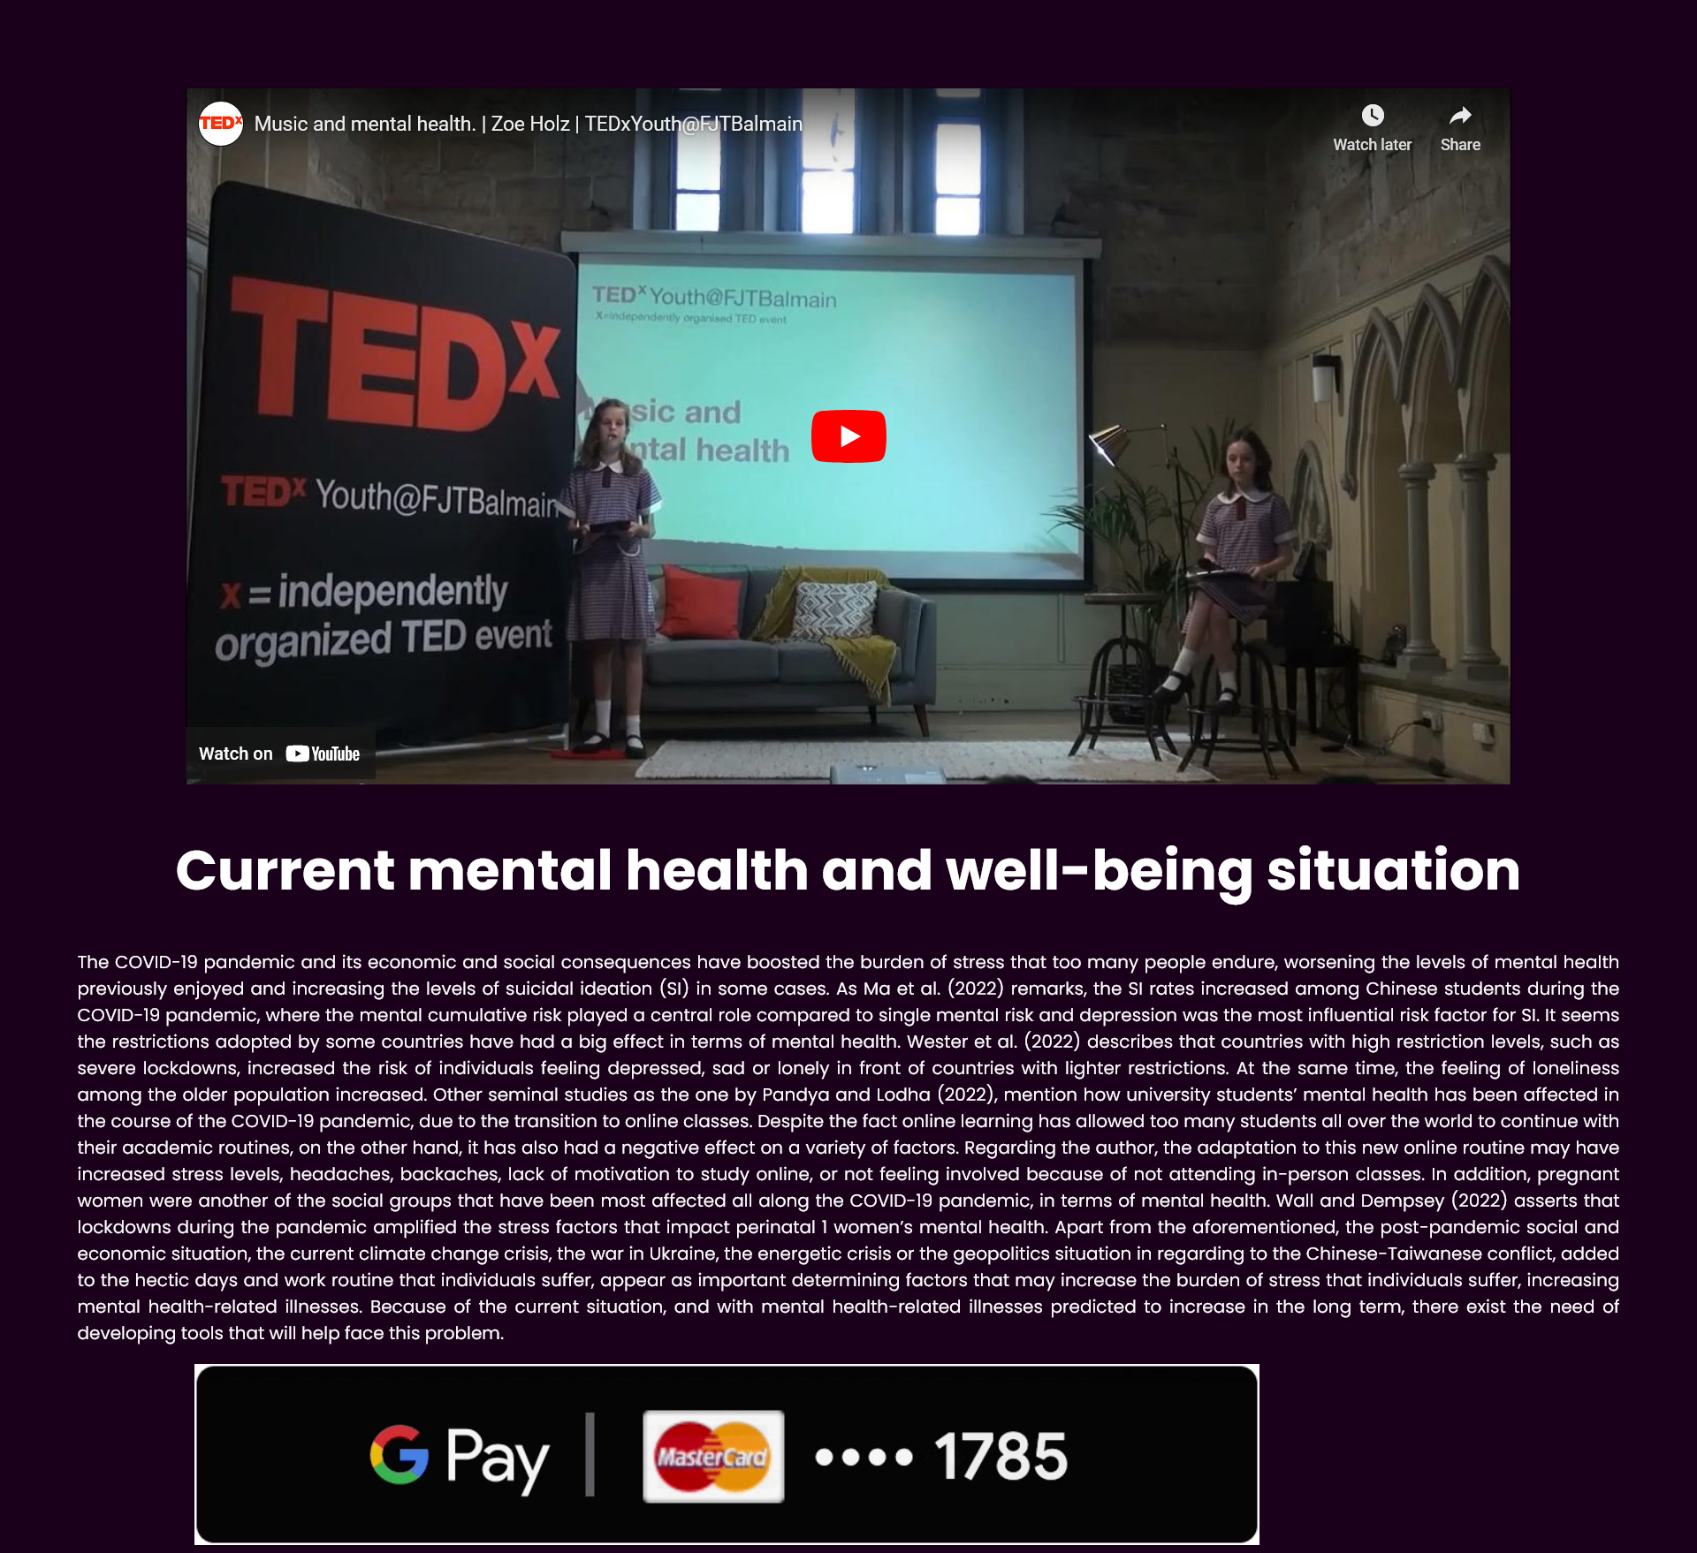

**7.Page3(html)**

<!DOCTYPE html>

<html lang="en">

<head>

<meta charset="UTF-8">

<meta http-equiv="X-UA-Compatible" content="IE=edge">

<meta name="viewport" content="width=device-width, initial-scale=1.0">

<title>p3</title>

<link rel="stylesheet" href="style2.css">

</head>

<body>

<center>

<div class="content">

<iframe width="1200" height="630" src="https://www.youtube.com/embed/JTmIn4T1kpA" title="YouTube video player" frameborder="0" allow="accelerometer; autoplay; clipboard-write; encrypted-media; gyroscope; picture-in-picture; web-share" allowfullscreen></iframe>

<h1> Current mental health and well-being situation</h1>

<p>The COVID-19 pandemic and its economic and social consequences have boosted the burden of stress that too many

people endure, worsening the levels of mental health previously enjoyed and increasing the levels of suicidal ideation

(SI) in some cases. As Ma et al. (2022) remarks, the SI rates increased among Chinese students during the COVID-19

pandemic, where the mental cumulative risk played a central role compared to single mental risk and depression was the

most influential risk factor for SI. It seems the restrictions adopted by some countries have had a big effect in terms

of mental health. Wester et al. (2022) describes that countries with high restriction levels, such as severe lockdowns,

increased the risk of individuals feeling depressed, sad or lonely in front of countries with lighter restrictions. At the

same time, the feeling of loneliness among the older population increased.

Other seminal studies as the one by Pandya and Lodha (2022), mention how university students’ mental health has

been affected in the course of the COVID-19 pandemic, due to the transition to online classes. Despite the fact online

learning has allowed too many students all over the world to continue with their academic routines, on the other hand, it

has also had a negative effect on a variety of factors. Regarding the author, the adaptation to this new online routine may

have increased stress levels, headaches, backaches, lack of motivation to study online, or not feeling involved because of

not attending in-person classes. In addition, pregnant women were another of the social groups that have been most

affected all along the COVID-19 pandemic, in terms of mental health. Wall and Dempsey (2022) asserts that lockdowns

during the pandemic amplified the stress factors that impact perinatal 1 women’s mental health.

Apart from the aforementioned, the post-pandemic social and economic situation, the current climate change crisis,

the war in Ukraine, the energetic crisis or the geopolitics situation in regarding to the Chinese-Taiwanese conflict, added

to the hectic days and work routine that individuals suffer, appear as important determining factors that may increase the

burden of stress that individuals suffer, increasing mental health-related illnesses. Because of the current situation, and

with mental health-related illnesses predicted to increase in the long term, there exist the need of developing tools that

will help face this problem.</p>

</div>

</center>

<marquee behavior="alternate" direction="left">

<a href="https://play.google.com/store/apps/details?id=com.google.android.apps.nbu.paisa.user&hl=en&gl=US">

<img src="dynamic button.gif" alt="">

</a>

</marquee>

</body>

</html>

**8.Page4**

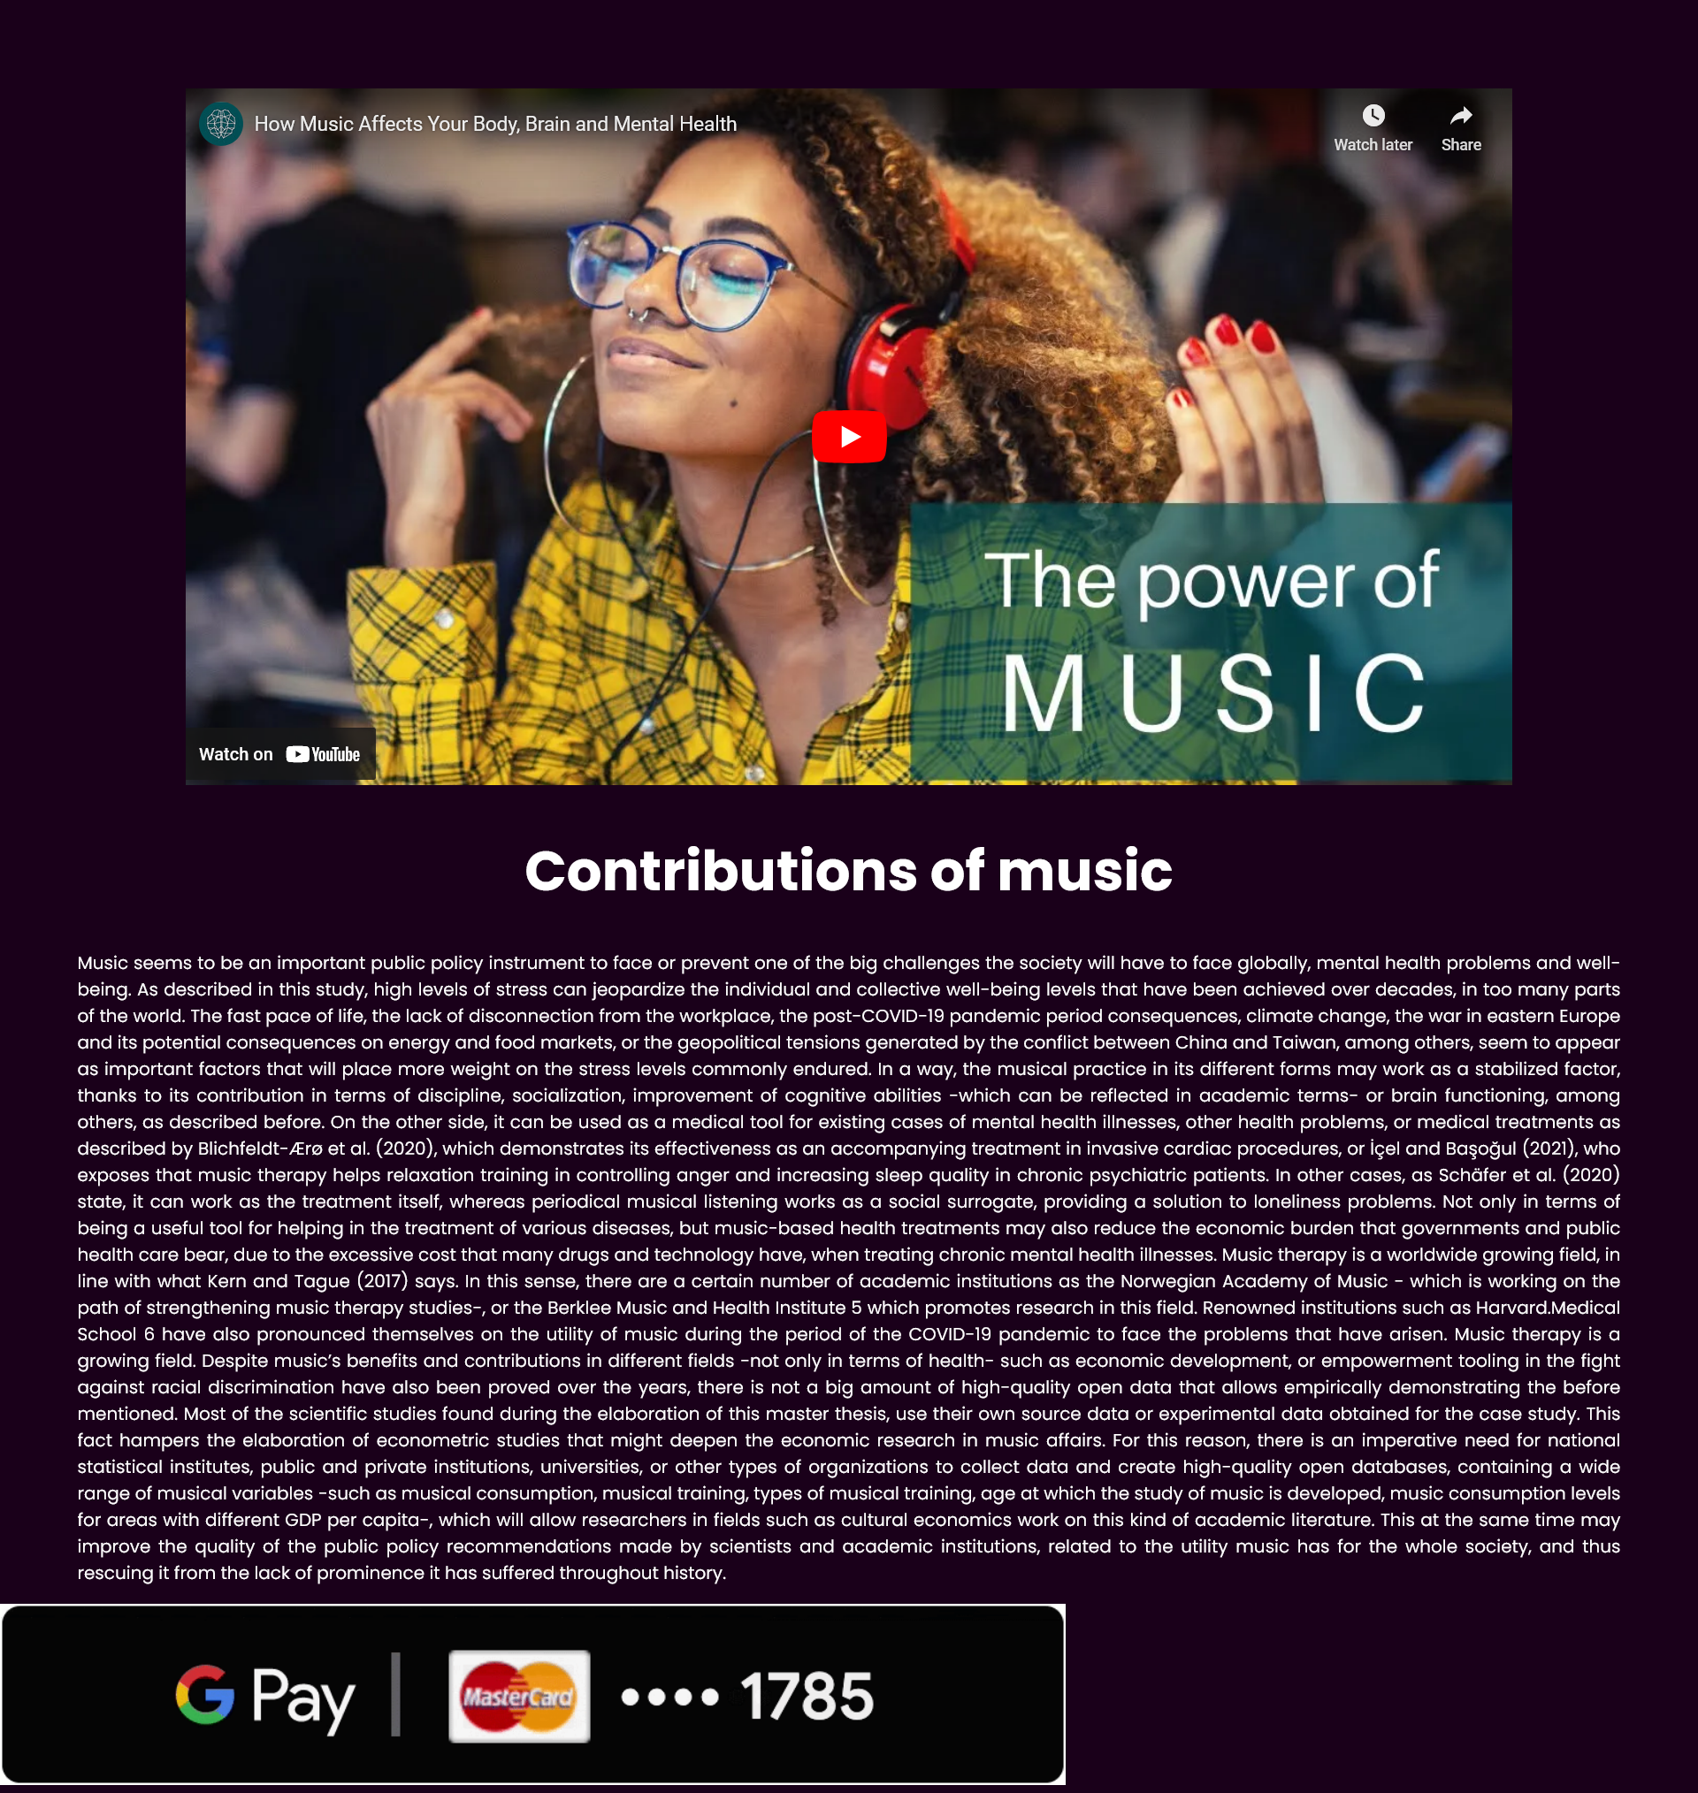

**9.Page4(html)**

<!DOCTYPE html>

<html lang="en">

<head>

<meta charset="UTF-8">

<meta http-equiv="X-UA-Compatible" content="IE=edge">

<meta name="viewport" content="width=device-width, initial-scale=1.0">

<title>p4</title>

<link rel="stylesheet" href="style2.css">

</head>

<body>

<center>

<div class="content">

<iframe width="1200" height="630" src="https://www.youtube.com/embed/mSzxk536Bw4" title="YouTube video player" frameborder="0" allow="accelerometer; autoplay; clipboard-write; encrypted-media; gyroscope; picture-in-picture; web-share" allowfullscreen></iframe>

<h1>More Information</h1>

<p>Music seems to be an important public policy instrument to face or prevent one of the big challenges the society will have

to face globally, mental health problems and well-being. As described in this study, high levels of stress can jeopardize

the individual and collective well-being levels that have been achieved over decades, in too many parts of the world.

The fast pace of life, the lack of disconnection from the workplace, the post-COVID-19 pandemic period consequences,

climate change, the war in eastern Europe and its potential consequences on energy and food markets, or the geopolitical

tensions generated by the conflict between China and Taiwan, among others, seem to appear as important factors that will

place more weight on the stress levels commonly endured. In a way, the musical practice in its different forms may work

as a stabilized factor, thanks to its contribution in terms of discipline, socialization, improvement of cognitive abilities

-which can be reflected in academic terms- or brain functioning, among others, as described before. On the other side, it

can be used as a medical tool for existing cases of mental health illnesses, other health problems, or medical treatments

as described by Blichfeldt-Ærø et al. (2020), which demonstrates its effectiveness as an accompanying treatment in

invasive cardiac procedures, or İçel and Başoğul (2021), who exposes that music therapy helps relaxation training in

controlling anger and increasing sleep quality in chronic psychiatric patients. In other cases, as Schäfer et al. (2020)

state, it can work as the treatment itself, whereas periodical musical listening works as a social surrogate, providing a

solution to loneliness problems.

Not only in terms of being a useful tool for helping in the treatment of various diseases, but music-based health

treatments may also reduce the economic burden that governments and public health care bear, due to the excessive

cost that many drugs and technology have, when treating chronic mental health illnesses. Music therapy is a worldwide

growing field, in line with what Kern and Tague (2017) says. In this sense, there are a certain number of academic

institutions as the Norwegian Academy of Music - which is working on the path of strengthening music therapy studies-,

or the Berklee Music and Health Institute 5 which promotes research in this field. Renowned institutions such as Harvard.Medical School 6 have also pronounced themselves on the utility of music during the period of the COVID-19 pandemic

to face the problems that have arisen.

Music therapy is a growing field. Despite music’s benefits and contributions in different fields -not only in terms of

health- such as economic development, or empowerment tooling in the fight against racial discrimination have also been

proved over the years, there is not a big amount of high-quality open data that allows empirically demonstrating the before

mentioned. Most of the scientific studies found during the elaboration of this master thesis, use their own source data or

experimental data obtained for the case study. This fact hampers the elaboration of econometric studies that might deepen

the economic research in music affairs. For this reason, there is an imperative need for national statistical institutes,

public and private institutions, universities, or other types of organizations to collect data and create high-quality open

databases, containing a wide range of musical variables -such as musical consumption, musical training, types of musical

training, age at which the study of music is developed, music consumption levels for areas with different GDP per capita-,

which will allow researchers in fields such as cultural economics work on this kind of academic literature. This at the

same time may improve the quality of the public policy recommendations made by scientists and academic institutions,

related to the utility music has for the whole society, and thus rescuing it from the lack of prominence it has suffered

throughout history.</p>

</div>

</center>

<marquee behavior="alternate" direction="left">

<a href="https://play.google.com/store/apps/details?id=com.google.android.apps.nbu.paisa.user&hl=en&gl=US">

<img src="dynamic button.gif" alt="">

</a>

</marquee>

</body>

</html>

**10.page 4,6,8(Combine CSS)**

@import url('https://fonts.googleapis.com/css2?family=Carter+One&family=Lobster&family=Montserrat:wght@100;300;500;700;900&family=Open+Sans:wght@300;700;800&family=Poppins:wght@100;200;300;400;500;700&display=swap');

body{

margin: 0px;

padding: 0px;

box-sizing: border-box;

font-family: 'poppins',sans-serif;

background-color: rgb(26, 0, 26);

}

.content h1{

color: #fff;

font-size: 50px;

}

.content p{

padding: 0 70px;

color: #fff;

text-align: justify;

}

.content iframe{

padding-top: 80px;

}

**11.JavaScript.**

let burger = document.querySelector('.hamburger');

let line = document.querySelectorAll('.line');

let cross = document.querySelector('.cross');

let list = document.querySelector('.list');

burger.addEventListener('click', () => {

line[0].classList.toggle('v');

line[1].classList.toggle('v');

line[2].classList.toggle('v');

cross.classList.toggle('v');

list.classList.toggle('v');

});

**Conclusion**

I would like to conclude the project. I have achieved the overall objective of developing a website with a series of web pages using HTML, CSS and JS.

The Project is based on web page designing and with this we are able to understand the significance of web page designing and coding in general. Overall the project has been a very inspiring and knowledgeable experience.

**Bibliography.**

[www.YouTube.com](http://www.YouTube.com)

<https://www.palladiumprivate.com/blog/6-benefits-of-music-for-your-mental-health/>

<https://www.nami.org/Blogs/NAMI-Blog/December-2016/The-Impact-of-Music-Therapy-on-Mental-Health>